How to map internal server ip with foreign server ip
with Cloud Integration service

1.Create Cloud Integration Service on public bluemix
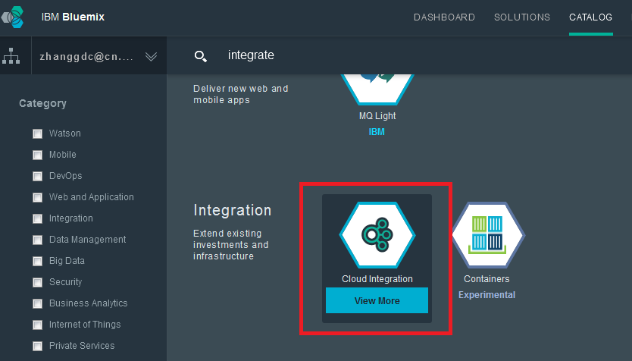

2. Enter Interface page of Service
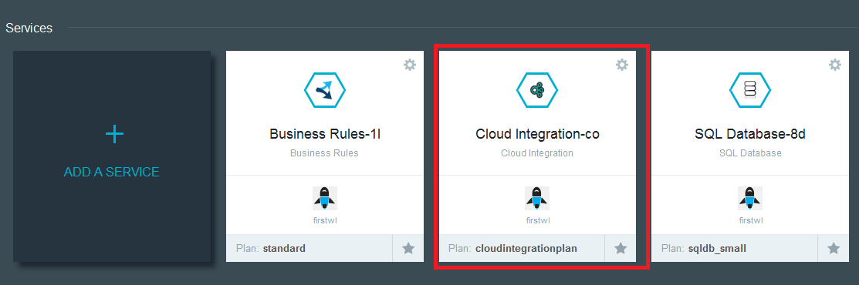

3. Enter Secure Connection interface page of service and create Basic connection

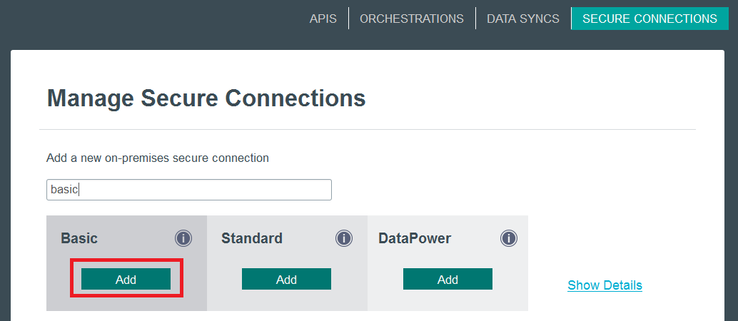

4. Download Native Secure Connector package.
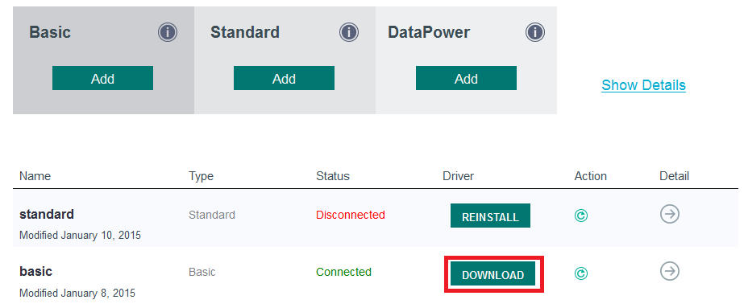

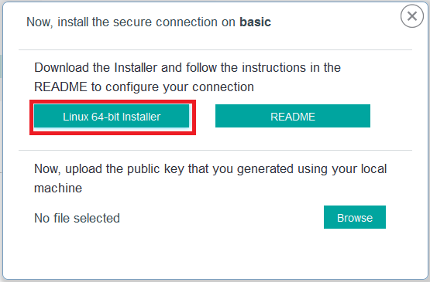

5. Native Secure Connector package can only be installed on below 3 types of OS.
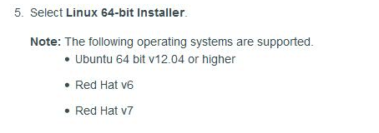

6. Check OS version of internal linux
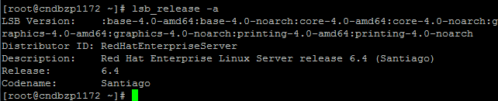

7.Installed Native Secure Connector package on internal linux


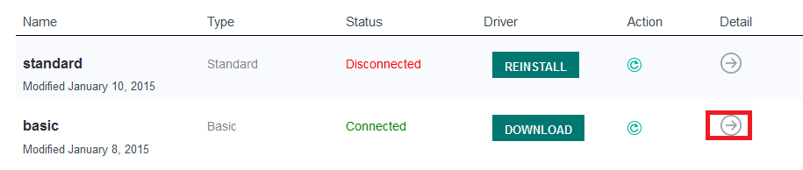

8.Add an Endpoint and input internal ip&port in property page
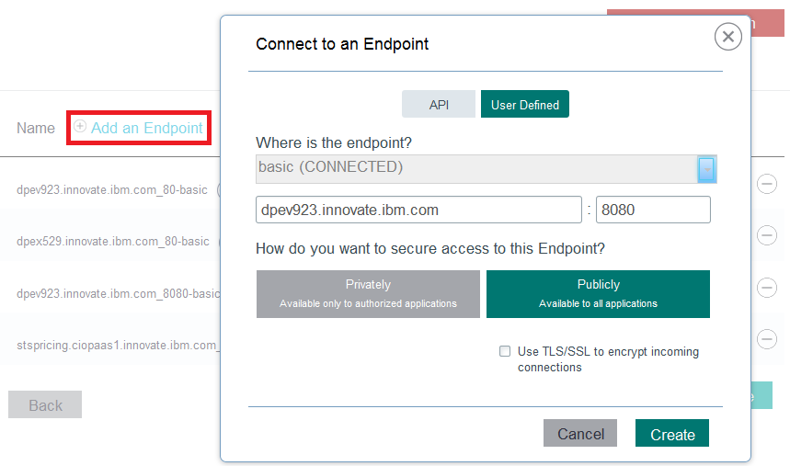

9.Get information of foreign IP&Port with clicking “i” char
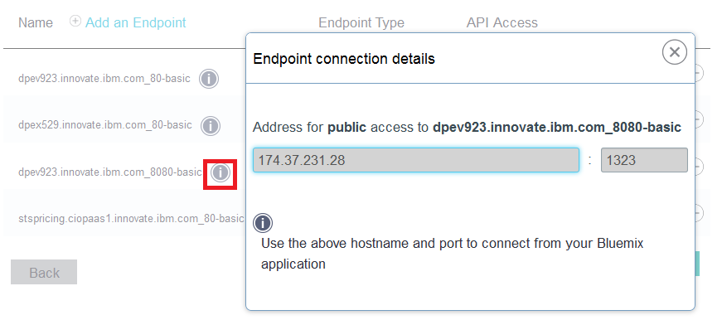

10.Confirm if foreign IP&port can work with accessing directly
